**Assignment 1 - Pi-Hole**

How it Works

A DNS server works by translating website domain names into IP addresses. A DNS client first sends a request, a URL, which the DNS server will have to communicate with its rootserver, Top-Level Domain (TLD), and the actual name server to return an IP address back to the client.

Pi-Hole works like similar to an adblocker since it can be configured to block DNS queries to certain known malicious, spam, and advertisement websites.

Integrating Pi-Hole as with your DHCP server means that all outside traffic must go through the Pi-Hole before reaching anyone within your LAN. Pi-hole’s DHCP server works like a regular DHCP server, distributing IP addresses for all within your network. The users on your LAN side are connected to the Pi-Hole, before being connected to the internet. This allows anyone connected within your LAN to be protected with Pi-Hole’s DNS blocking without needing any extra setup and configuration.

Installation - Configure your Static IP

The following installation guide is meant for Ubuntu Linux 22.04.

Before installing Pi-Hole. We need to set a static IP for ourselves. In the terminal,

type nmcli d . This will show the name of your network. Mine here is enp0s3.

Next, type ip route . This will tell you what your network’s default gateway is. Here mine is 10.0.2.2 . Remember these two for later.

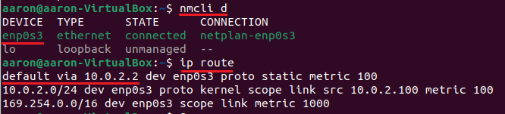

Locate your netplan config file. Navigate with cd /etc/netplan . Look for a .yaml file that is named similar to the one below.



We’ll use nano to edit the text of the .yaml file. Write sudo nano YOUR_FILENAME.yaml . It will likely prompt your for your password.



Once you’re into the file editor, it will look something like this.

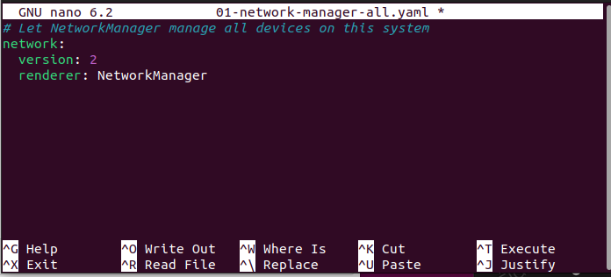

You’re going to want to enter your own network’s information in the format seen below.

As an example here, enp0s3 is the name of my network.

The static IP that I chose to set is 10.0.2.100 .

The default gateway is 10.0.2.2 .

The DNS servers are Google’s DNS servers.

IMPORTANT: use two (2) spaces for indents. Do not use tabs or the .yaml file will not work.

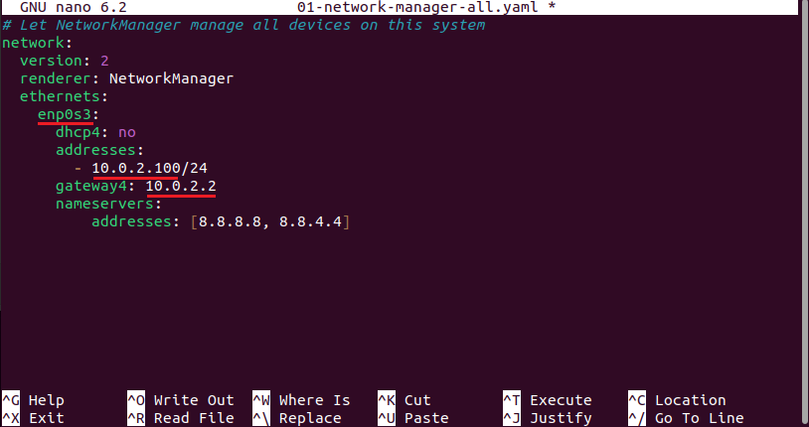

When you’re finished, press CTRL+X to exit. Then yes to save your work.

Then run sudo netplan apply . to apply your changes. You may have to restart your computer for the changes to take into effect.

Congrats! You have now set a static IP address.

Installation - Installing Pi-Hole on Your Computer

We will be using the One-Step Automated Install.

For alternate install methods, go to <https://pi-hole.net/>.

Run curl -sSL https://install.pi-hole.net | bash on in your terminal. You may need to install curl if you have not done so before. You will be prompted with a GUI.

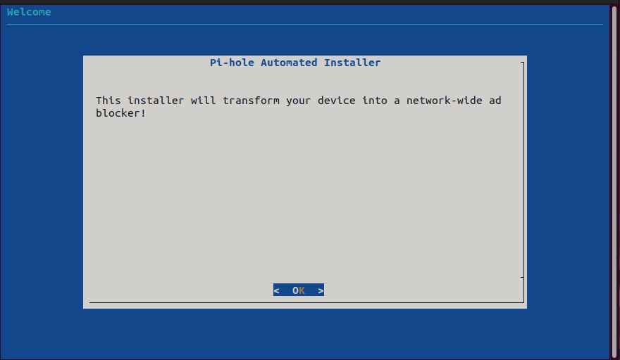

Navigate through the installer. You’ll want to select Google as your Upstream DNS provider.

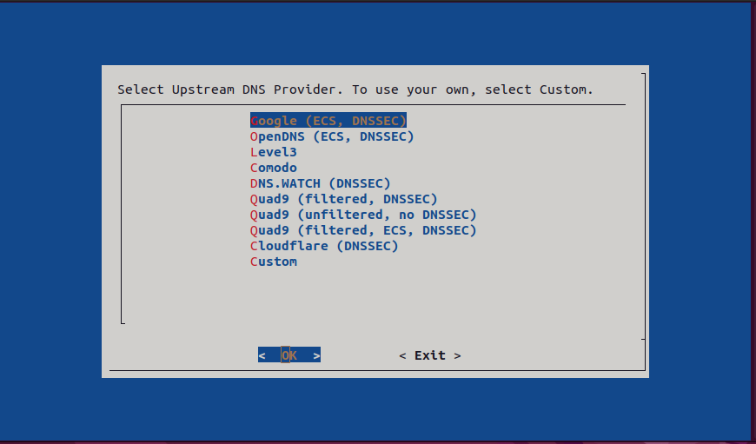

As a first time user, it is fine to use the provided blocklist. You may add and modify blocklists later on.

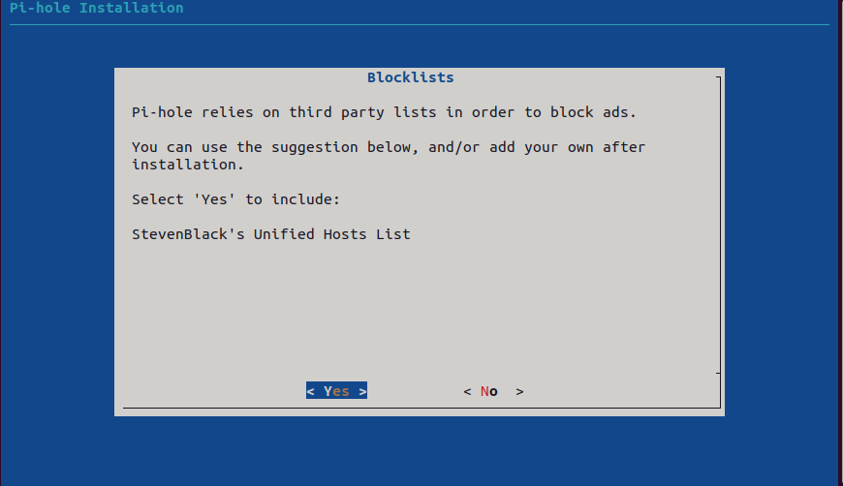

Yes, we will want the admin web interface.

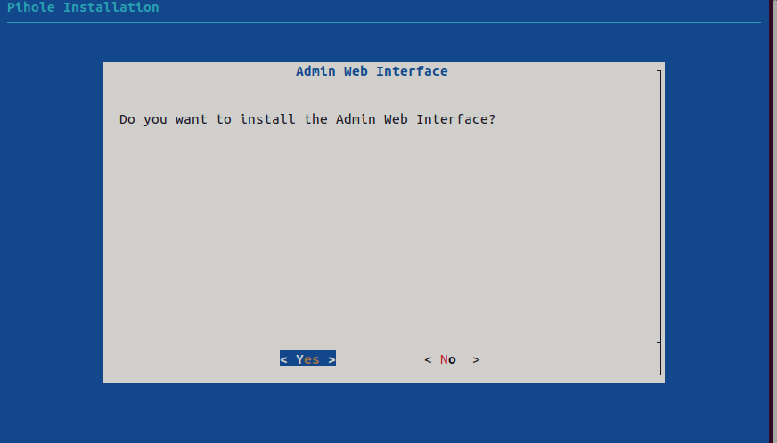

When your installation is complete, you will be prompted with this screen. From your browser, use one of the two given URLs to access the web interface. Remember your password for logging in.

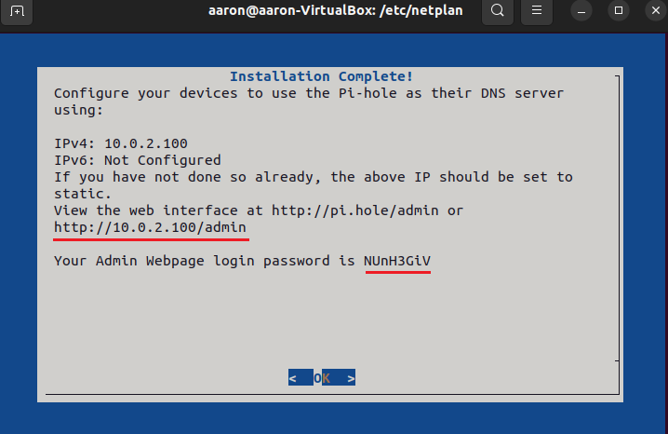

Login to the web interface using your given login details.

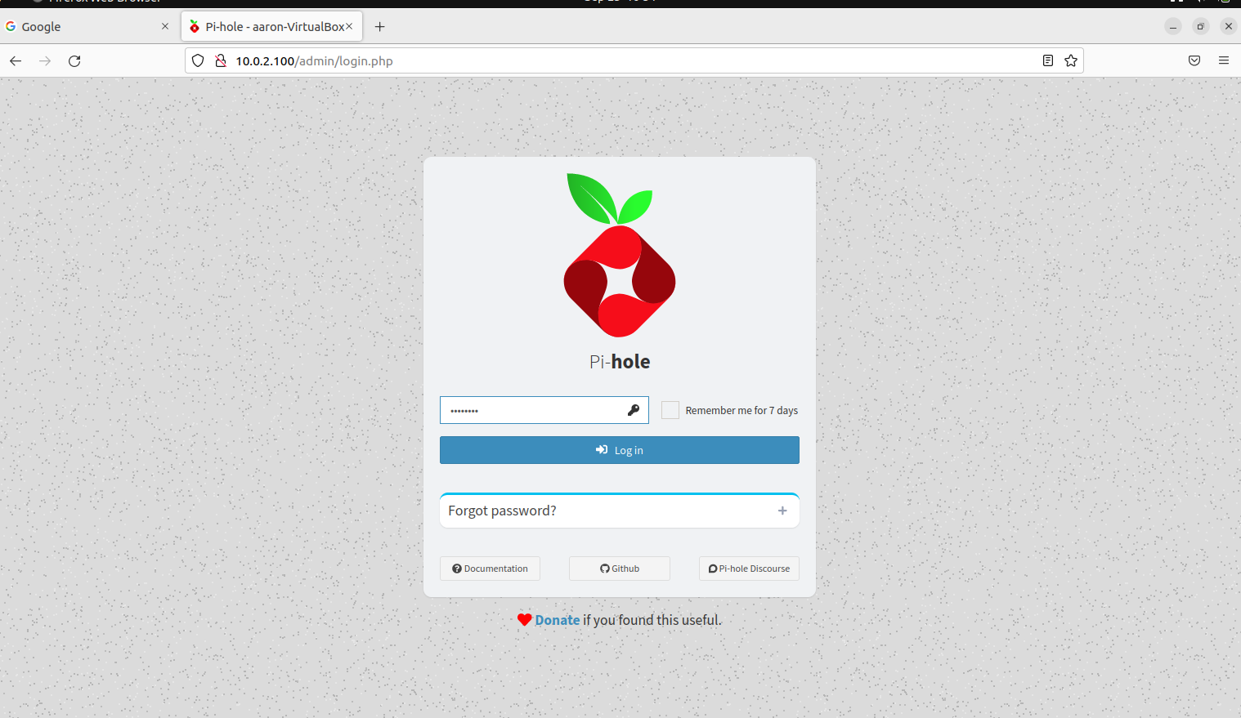

When you’re logged in, it should look like this.

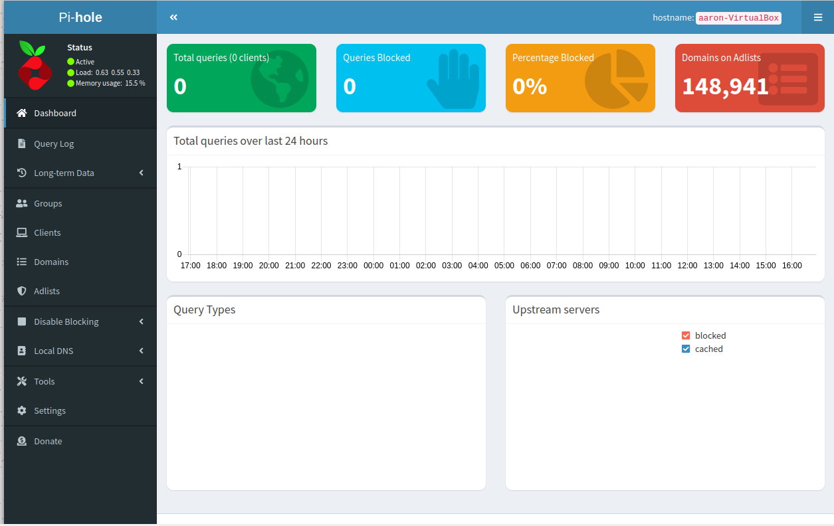

Go back to your netplan .yaml file, should still be in /etc/netplan . And change your DNS nameserver from Google’s to your Pi-Hole’s. This address should be the same as the one used to login to Pi-Hole’s web interface.

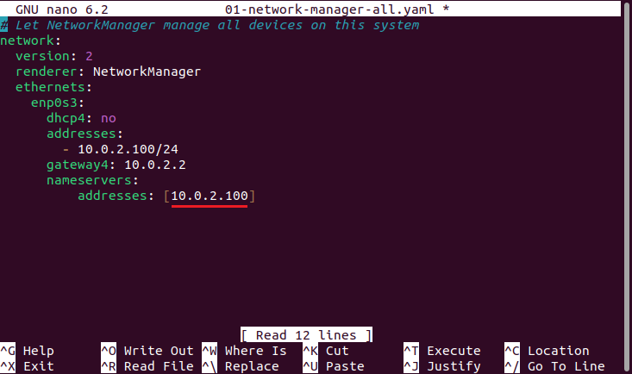

Again CTRL+X to exit. Save. And sudo netplan apply to apply your changes.

Now try going to a spam website on the blocklist (try doubleclick.net). You should be blocked from it. Also try regular websites such as google.com to make sure not blocked from everything.

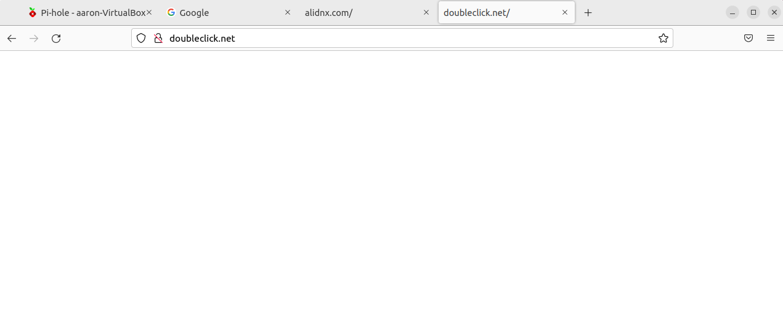

Returning to your Pi-Hole web interface, you should see that you have some queries that have been blocked. Congrats! You now have Pi-Hole configured on your computer.

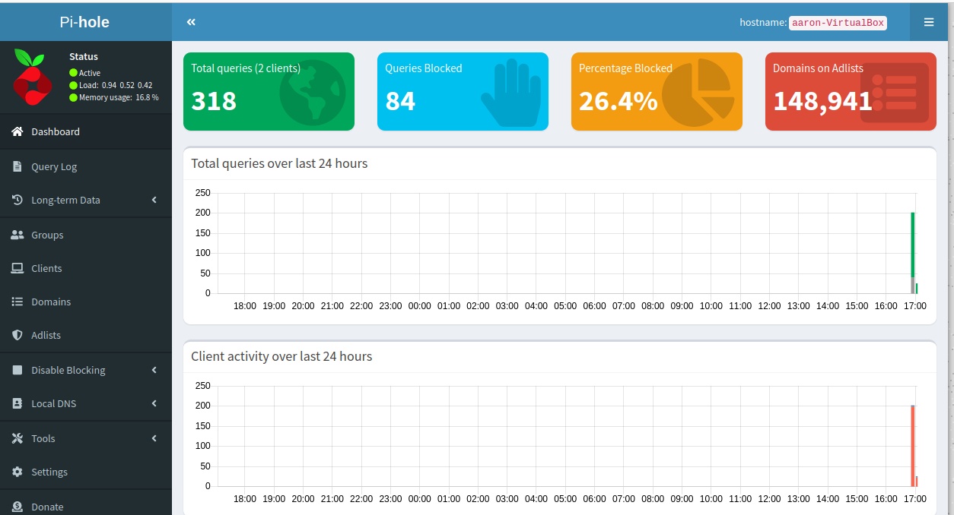

Configure Pi-Hole for Your Router

Login to your router using your default gateway.

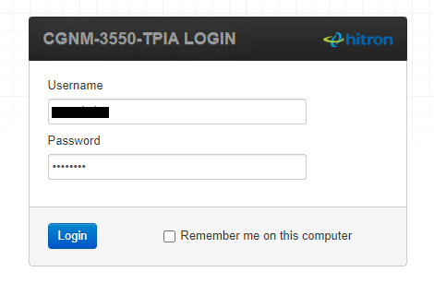

Navigate to your DNS settings and change the DNS to your Pi-Hole.

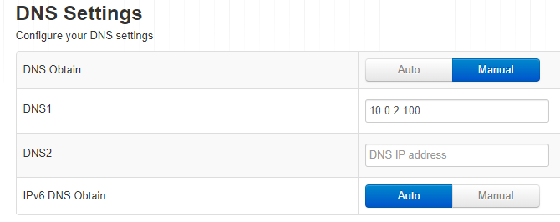

Navigate back to your Pi-Hole web interface. Go to Settings > DNS. Make sure at least one of the upstream DNS servers is selected.

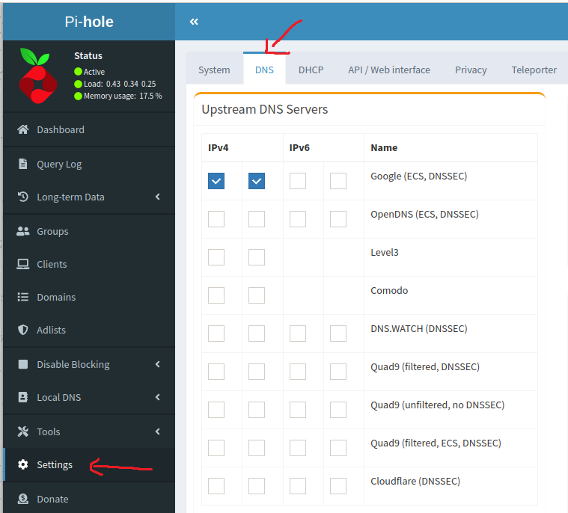

Congrats! Clients in your network will go through Pi-Hole before connecting to the web.

Issues Encountered

My laptop runs on Windows 11, which is incompatible with Pi-Hole. I had to install a VirtualBox VM to run Ubuntu Linux. Going through a VM has a series of issues and new things that I had to learn in order to get everything to run as I intended.

Another issue is that, I first installed Pi-Hole as a test run to see if it works. Since I forgot to document my procedure, I then had to *uninstall* Pi-Hole and reinstall it, documenting with proper screenshots. (This was done twice since I had missed some screenshots that were necessary to the written tutorial). I set my DNS server to Pi-Hole’s DNS server at 10.0.2.100. After uninstalling Pi-Hole, I was left with no internet since the DNS server my computer pointed to no longer existed. After 30 minutes of troubleshooting, I figured out that I am supposed to reconfigure my network to Google’s DNS servers such that I could download and reinstall Pi-Hole and then switch back to Pi-Hole’s DNS server to allow it to work again.

This was painful.

References

<https://www.cloudflare.com/learning/dns/what-is-a-dns-server/>

<https://www.cloudns.net/blog/dhcp-server/>

<https://itsfoss.com/static-ip-ubuntu/>

<https://discourse.pi-hole.net/t/how-do-i-configure-my-devices-to-use-pi-hole-as-their-dns-server/245>